**CIND 719 Assignment 2 Chantal Sylvestre**

--Made assignment2 directory on linux machine

mkdir /home/assignment2

-- Used filezilla to move tgz file to linux machine then extracted files

tar xvf /home/lab/flight.tgz -C /home/assignment2/

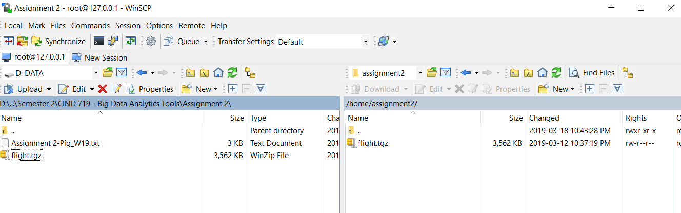

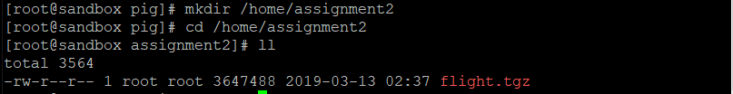

--Made a directory on HDFS

hadoop fs -mkdir /user/pig/a2

--Put extracted files onto HDFS

hadoop fs -put /home/assignment2/*.* /user/pig/a2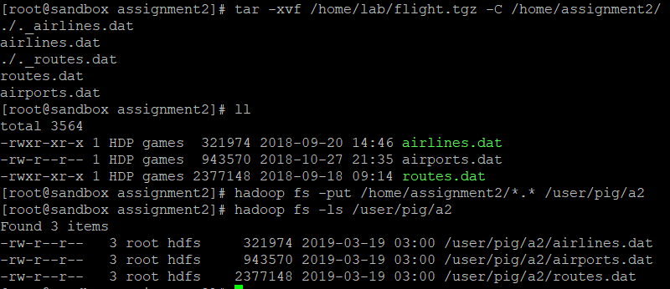

--The first few lines of the airlines dataset:

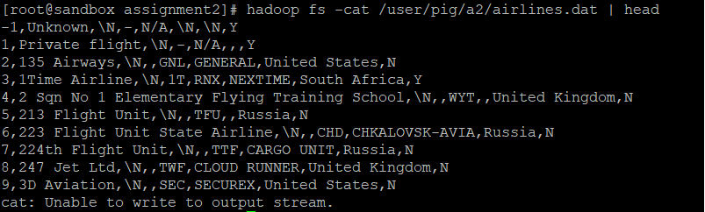

-------------------------

----QUESTION 1----

-------------------------

--Load airlines dataset into pig

airlines = LOAD '/user/pig/a2/airlines.dat' using PigStorage(',') AS (airline_id:chararray, airline_name:chararray, airline_alias:chararray, airline_iata:chararray, airline_icao:chararray, airline_call:chararray, airline_country:chararray, airline_active:chararray);

--Filtered for air canada, case insensitive with or without a space using Regex

air_canada = FILTER airlines BY airline_name MATCHES '(?i).*air.?canada.*';

--Generate only the necessary fields

air_canada2 = foreach air_canada GENERATE airline_id, airline_name;

--Output

dump air_canada2;

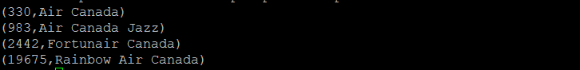

------------------------

----QUESTION 2----

------------------------

--load in the airports dataset

airports = LOAD '/user/pig/a2/airports.dat' using PigStorage(',') AS (airport_id:int, airport_name:chararray, airport_city:chararray, airport_country:chararray, airport_iata:chararray, airport_icao:chararray, airport_lat:float, airport_lon:float, airport_alt:chararray, airport_tz:chararray, airport_dst:chararray, airport_timezone:chararray, airport_source:chararray);

-- grouped by country

airport_country = GROUP airports BY airport_country;

--count the number of airports per country

airport_count = FOREACH airport_country GENERATE group AS country, COUNT(airports) AS count;

--order data descending

airport_order = ORDER airport_count by count DESC;

--limit to the top 5 highest number of airports per country

airport_top = limit airport_order 5;

--output for question 2

dump airport_top;

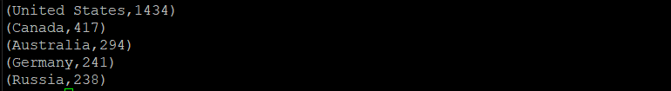

------------------------

----QUESTION 3----

------------------------

--load routes dataset

routes = LOAD '/user/pig/a2/routes.dat' using PigStorage(',') AS (r_airline:chararray, r_airline_id:int, r_source:chararray, r_source_id:int, r_dst:chararray, r_dst_id:int, r_code:chararray, r_stops:chararray, r_eq:chararray);

--selecting the information I want displayed

routes2 = foreach routes generate r_source, r_source_id, r_dst, r_dst_id;

-- only selecting the distinct rows so there are no duplicate routes in the output

routes3 = distinct routes2;

--limiting by 5 to display first 5 rows

routes4 = limit routes3 5;

--question 3 output

dump routes4;

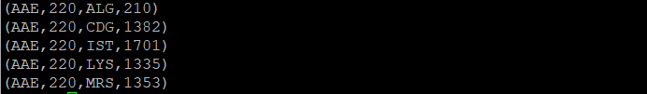

-------------------------

----QUESTION 4----

-------------------------

--load in necessary data from airports dataset

lat_lon = foreach airports generate airport_iata, airport_id, airport_name, airport_lat, airport_lon;

--join the airport data to the route source data to link the lat and lon and airport name

src_loc = join lat_lon by airport_iata, routes3 by r_source;

--rename the lat and lon and airport name and id to indicate that these are linked to the source airport for the route

src_loc2 = foreach src_loc generate lat_lon::airport_iata, lat_lon::airport_id as s_id, lat_lon::airport_name as s_name, lat_lon::airport_lat as lat1, lat_lon::airport_lon as lon1, routes3::r_dst, routes3::r_dst_id;

--join the airport data to the route destination data to link the lat and lon and airport name

dst_loc = join lat_lon by airport_iata, src_loc2 by r_dst;

--generated the required data for both the source and destination data into a variable

dst_src = foreach dst_loc generate lat_lon::airport_name as dst_name, lat_lon::airport_id as dst_id, lat_lon::airport_lat as lat2, lat_lon::airport_lon as lon2, src_loc2::s_name, src_loc2::s_id as s_id, src_loc2::lat1, src_loc2::lon1;

--calculated the distance and then generated the desired fields using a nested foreach

d = foreach dst_src {

distance = SQRT((lat2 - lat1) * (lat2 - lat1) + (lon2 - lon1) * (lon2 - lon1)) * 111;

generate s_id, s_name, dst_id, dst_name, distance;};

--limit 5 to output the first 5 rows

e = limit d 5;

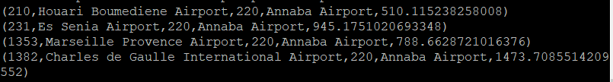

--stored output as a directory on the Hadoop fs

store d into '/user/pig/a2/routes_with_distances';

